ComicCraft – AI Comic Story Creator powered by Gemini & Stable Diffusion
Project Design Phase-II
Technology Stack (Architecture & Stack)
Date | 28/09/2026
Team ID | SWTID-2026-1512
Project Name | ComicCraft

Team Leader: LAKSHMIPRIYA M | Team Members: KAVIYA K, KIRTHANA, KOWSALYA M
Technical Architecture:
The system follows a layered architecture. The user's browser sends a request to a FastAPI backend. Request data is validated with Pydantic, then processed by a chain of service modules: Gemini outline generation, Gemini script expansion, panel image generation, layout building, and PDF export. HTML pages are rendered with Jinja2 templates, and generated images and PDFs are stored in the static folder.
The deliverable includes the architectural diagram below along with the component and characteristic tables.
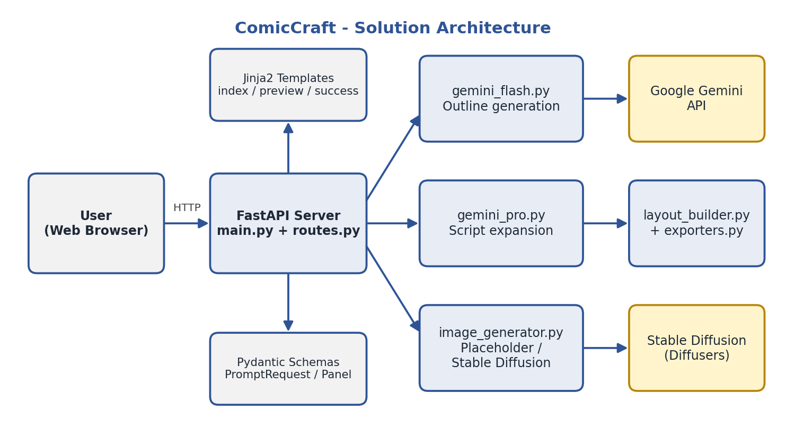
Figure 1: ComicCraft technical architecture
Table-1: Components & Technologies
S.No | Component | Description | Technology
1 | User Interface | Story input form, comic preview page, and export success page | HTML, CSS, JavaScript, Jinja2
2 | Application Logic-1 | Routing, request handling, and validation | Python, FastAPI, Pydantic, Uvicorn
3 | Application Logic-2 | Comic outline and script generation | Google Gemini API (google-genai)
4 | Application Logic-3 | Panel image generation | Pillow (placeholder), Hugging Face Diffusers, Stable Diffusion
5 | Layout & Export | Combines text and images, produces the PDF | Python, FPDF2
6 | Configuration | Environment-based settings for keys, models, and image size | pydantic-settings, python-dotenv
7 | File Storage | Stores generated panel images and exported PDFs | Local file system (static/panels, static/exports)

Table-2: Application Characteristics
S.No | Characteristics | Description | Technology
1 | Open-Source Frameworks | Frameworks and libraries used in the system | FastAPI, Jinja2, Pydantic, Pillow, FPDF2, Diffusers
2 | Modular Architecture | Separate service modules for each stage of the pipeline | Python service layer
3 | Security | API keys stored in environment variables, not in code | .env, pydantic-settings
4 | AI Integration | Story generation and image generation | Gemini (gemini-2.5-flash), Stable Diffusion v1.5
5 | Flexible Image Modes | Fast placeholder mode for testing, real AI mode for final output | IMAGE_PROVIDER = placeholder / diffusers
6 | Testing | Automated checks for health and home page | pytest, FastAPI TestClient

